Society of Health and Physical Educators (SHAPE America)
Physical and Health Education Canada (PHE Canada)

The North American Society (NAS) recognizes outstanding professionals from within the allied professions of health education, physical education, recreation, sport and dance in North America.

2023 Fellows

Brett Fuller
Milwaukee Public Schools, WI (retired)

Brett Fuller is the retired curriculum specialist for health and physical education within Milwaukee Public Schools; Wisconsin’s largest district which supports 165 physical education teachers. His career spans three decades, and in that time his philosophy has centered upon the ideal of teaching students to be healthy for a lifetime. He believes in improvement of physical educations not only at the district level, but within the state of Wisconsin and the nation. He has presented and been published locally, at the state level, and nationally on topics ranging from bullying in physical education, sex education, equity, inclusion and diversity. Brett served on the Wisconsin Governor’s Council on Physical Fitness and Health and on the Healthy Wisconsin 2020 task force on physical activity. He is a past president of Wisconsin Health and Physical Education, and a past President of the Society of Health and Physical Educators (SHAPE America).

Tao Zhang
University of North Texas
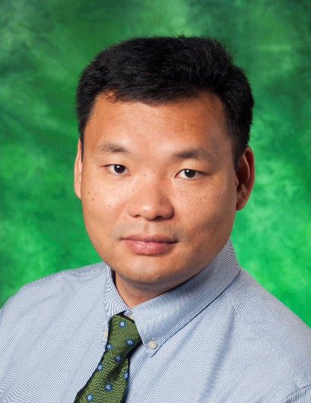

Dr. Tao Zhang is a full professor in the Department of Kinesiology, Health Promotion and Recreation at the University of North Texas (UNT) where he serves as Pediatric Movement and Physical Activity Laboratory Director. He earned his bachelor’s and master’s degrees in Kinesiology from Shanghai University of Sport, and his Ph.D. in Kinesiology from Louisiana State University. Dr. Zhang has made more than 170 research presentations at international, national, and state conferences, published about 98 refereed research articles, authored about 110 peerreviewed research abstracts and conference papers, and awarded about 20 funded research projects from federal agencies and research foundations. His research focuses on supportive physical activity environments, achievement motivation, motor skill, and physical activity and health promotion from psychological, pedagogical, and behavioral perspectives. He was inducted as a Research Fellow in the Society of Health and Physical Educators (SHAPE America) in 2012, won the Mabel Lee Award in 2013, earned the Mentor of the Year Award in 2017, won the Joy of Effort Award f in 2020, and earned the Curriculum and Instruction Honor Award in 2022. Since 2010, he has mentored graduate students who have received over 25 awards for their research. He serves as the Editor-in-Chief, Associate Editor, and Editorial Board Members for multiple journals such as Journal of Teaching in Physical Education, International Journal of Behavioral Nutrition and Physical Activity. He has also served on several committees of professional organizations. Recently, Dr. Zhang was inducted as a Fellow of American College of Sports Medicine (ACSM) in 2020.

